**Reactjs Components**

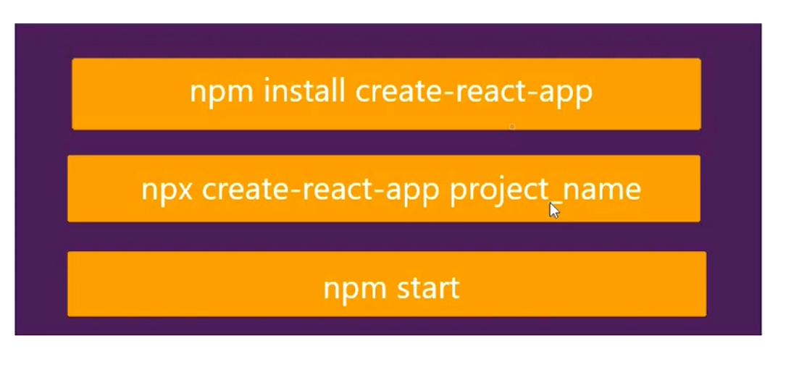

Note: if we want use multiple html tag we must me declare 1 parent declare like

<div>

<h1></h1>

<button></button>

</div>

State:

state is a like a variable..it we can store data like dictionary..in state place we can take any variable

Ex : state={‘name’:’chandu’,’age’:25},data= {‘name’:’chandu’,’age’:25}

Usage: return({this.state.name},{this.state.age})

Pops:

It transfers the value one file to another file or parent class to child class

Syntax: name=this.props.sending value….image 1 is 2nd file…img 2 is main

CSS File Linking: 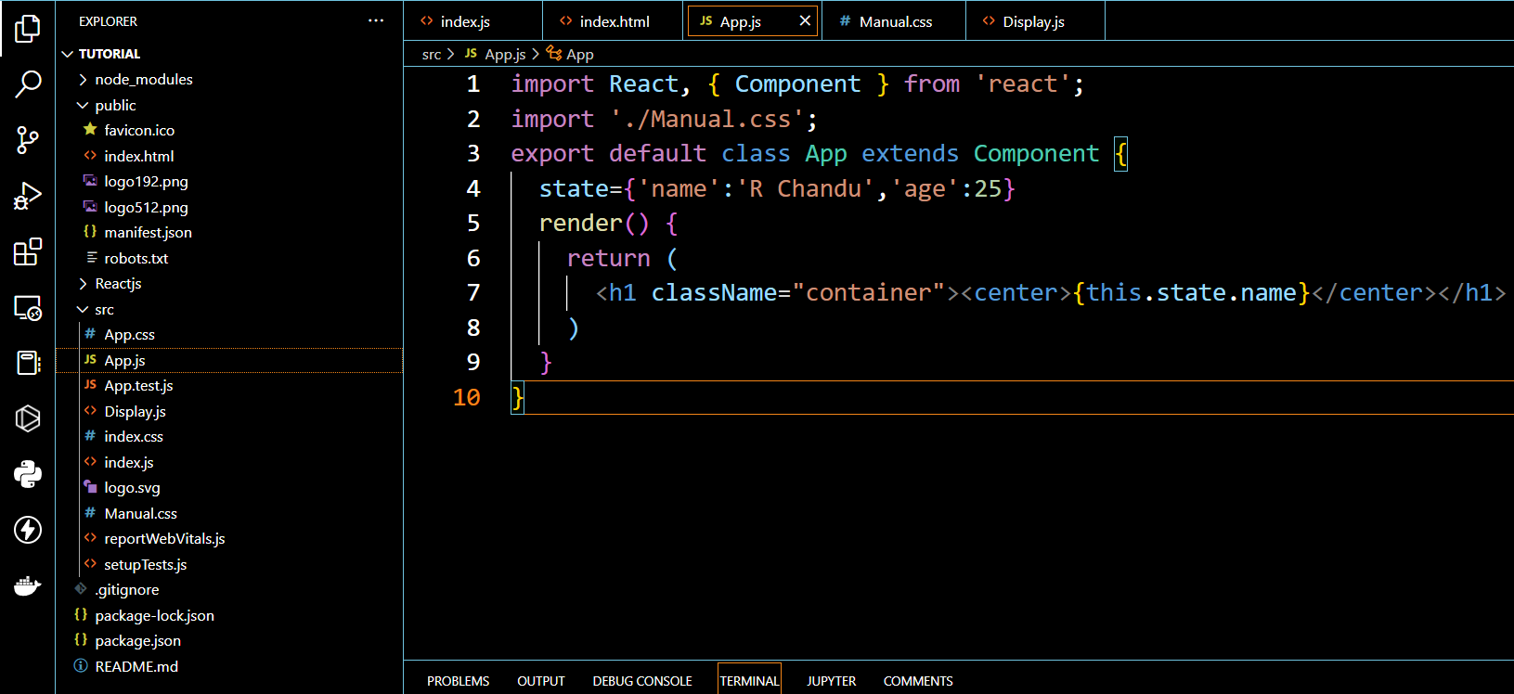

In Line Css:

1.code must be write {{}} inner of the flower brockets only

2.in case property name is graterthan 1 like text-align or background-color in react must be write like this textAlign,backgroundColor

3. property value must be specify in double quotes only “ ”,and never use semicolon ;..after completing the one property must be use kama ,. This is also one method Ex :

style={{color:"crimson",fontSize:"80px",backgroundColor:"lightgrey"}}

another method is taking the one variable..we can menction that styles in that variable

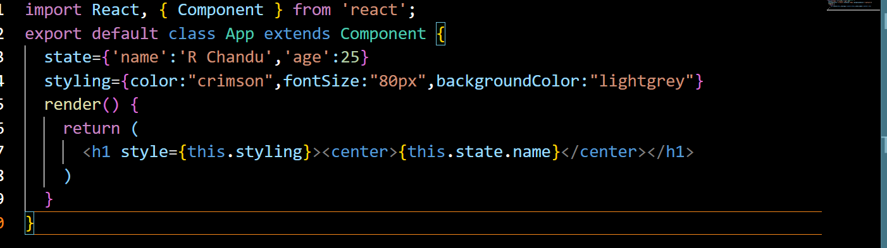

**

useState:

it changes one state to another name..

syntax : const [name,Newname]=useState(“chandu”) its actual name

when I click the button it need to be change R Chandu

so we use Newname(“R Chandu”)

import React,{useState} from 'react'

const App=() =>{

  const [name,newName]=useState('chandu');

  return(<div>

    <center><h1>{name}</h1></center>

    <button onClick={()=>newName("R Chandu")}>ClickMe</button>

    <button onClick={()=>newName("R Chandu Chitti")}>ClickMe</button>

  </div>)

}

export default App;

useEffect:

when the return statement is excuted,instantly useEffect will be excuted..like a after b after c….

in first value we must pass the function,2nd position pass the dependency (optional)…incase we pass dependency value ..when dependency value is change,,.useEffect will be excuted…

import React,{useState,useEffect} from 'react'

const App=() =>{

  const [count,NewCount]=useState(0)

  useEffect(() =>console.log("clicked"),[count])

  return(

    <div>

      <center>

        <h1>{count}</h1>

        <button onClick={()=>NewCount(count+1)}>Click Me</button>

      </center>

    </div>

  )

}

export default App

onChange:

when change is occurred in the variable ,that it will be excute

import React,{useState} from 'react'

const App=() =>{

  const [name,NewName]=useState("chandu")

  const handler=e =>{

    NewName(e.target.value)

  }

  return(

    <div>

      <center>

        < input type="text" value={name} onChange={handler}></input>

        <h1>{name}</h1>

      </center>

    </div>

  )

}

export default App

onSubmit:

import React,{useState} from 'react'

const App=() =>{

  const [data,setData]=useState({username:'',password:'',})

  const {username,password}=data

  const onchangeHandler=e=>{

    setData({...data,[e.target.name]:[e.target.value]})

  }

  const onsubmitHandler=e=>{

    //incase any defaults are there..it will removes

e.preventDefault();

    console.log(data);

  }

  return(

    <div>

      <center>

        <form onSubmit={onsubmitHandler}>

          < input type="text" value={username} name='username' placeholder="username" value={username} onChange={onchangeHandler}/>

          <input type="password" value={password} name="password" placeholder="password" value={password} onChange={onchangeHandler}/>

          <input type="submit" value="submit"></input>

        </form>

      </center>

    </div>

  )

}

export default App

map :

it iterates the iterable value..must be pass the function ..

import React from 'react'

const App=() =>{

  const arr=['a', 'b', 'c']

  const dict=[{id:1,name:'chandu'},{id:2,name:'ram'}]

  return(

    <div>

        {arr.map(

          (value,index)=><li key={index}>{value}</li>

        )}

      {dict.map(

        (value,id)=><li key={id}>{value.id}{value.name}</li>)}

    </div>

  )

}

export default App

filter :

it filters the required values..

import React from 'react'

const App=() =>{

  const arr=['ram', 'nag', 'ramesh','raghu']

  const filtered=arr.filter(names=>names.includes('r'))

  return(

    <div>

      {filtered.map(

        (value,index)=><li key={index}>{value}</li>

      )}

    </div>

  )

}

export default App

export :

import React from 'react'

export const Display=() =>{

  return(

    <div>

      <centered><h1>testing</h1></centered>

    </div>

  )

}

import React from 'react'

//importing display from Display.js

import {Display} from './Display'

const App=() =>{

  return(

    <div>

      <centered><Display/></centered>

    </div>

  )

}

export default App

eval:

it automatically evaluates the expression

ex: its an string form……10+25

out put : 35

2*10=20

..it will automatically converted string to evaluation form..

Syntax: eval{input_string_expression}

fetch:

It used for get the data from api,or make http requests

//importing display from Display.js

import React ,{useEffect, useState} from 'react'

const App=() =>{

  const[data,setData]=useState([]);

useEffect(() =>{

  fetch('https://jsonplaceholder.typicode.com/todos').then(

    resp=>resp.json()).then(json=>setData(json))

})

return(

  <div>

    {data.map(item=> <li key={item.id}>{item.title}</li>)}

  </div>

)

}

export default App

**Using axios for Get API :**

import axios from 'axios'

import { useState } from 'react'

const AxiosGetNuera=()=>{

    const [api_data,newdata]=useState([])

    axios.get('https://jsonplaceholder.typicode.com/todos').then(data=>{newdata(data.data)})

    return(

        <div>

            <h1>from axios</h1>

            {api_data.map(item=><li key={item.id}>{item.title}</li>)}

        </div>

    )

}

export default AxiosGetNuera

**Using Google Firebase**

import React,{useState} from 'react'

import axios from 'axios'

const GoogleFireBase=() =>{

  const [data,setData]=useState({fullname:'',username:'',password:'',})

  const {fullname,username,password}=data

  const onchangeHandler=e=>{

    setData({...data,[e.target.name]:[e.target.value]})

  }

  const onsubmitHandler=e=>{

    //incase any defaults are there..it will removes

e.preventDefault();

    axios.post('https://react-tutorial-963d3-default-rtdb.firebaseio.com/react_post.json',data).then(()=>{console.log('succesfully posted')});

  }

  return(

    <div>

      <center>

        <form onSubmit={onsubmitHandler}>

            <input type='text' value={fullname} name='fullname' placeholder='fullname' onChange={onchangeHandler}/>

          <input type="text" value={username} name='username' placeholder="username"  onChange={onchangeHandler}/>

          <input type="password" value={password} name="password" placeholder="password" onChange={onchangeHandler}/>

          <input type="submit" value="submit"></input>

        </form>

      </center>

    </div>

  )

}

export default GoogleFireBase

**React Routers :**

**It uses for multi page application..purpose…it will loads the all urls data..at time loads all data.**

 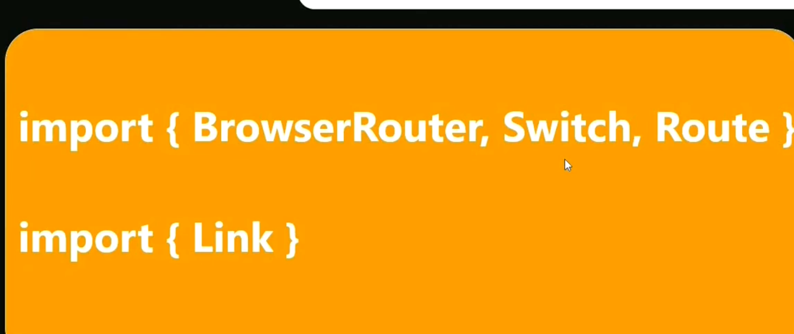 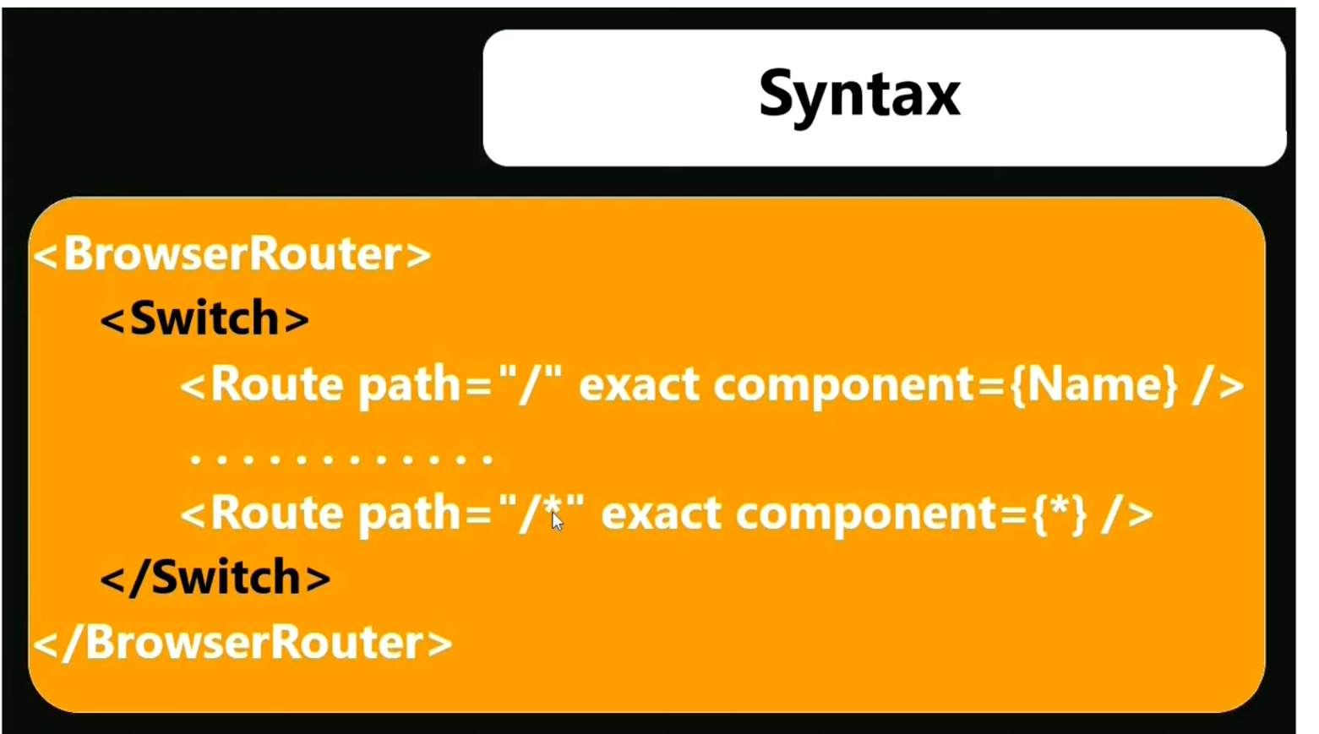

**App.js**

import React ,{Component} from 'react'

import Props from './components_Nuera/Props'

import {BrowserRouter,Routes, Route} from 'react-router-dom'

import { Login } from './components_Nuera/react_router_Nuera'

import { About } from './components_Nuera/react_router_Nuera'

import { Register } from './components_Nuera/react_router_Nuera'

const App =()=>{

  return(

    <BrowserRouter>

      <Dashboard/>

      <Routes>

        <Route path='/Login' Component={Login}/>

        <Route path='/Register' Component={Register}/>

        <Route path='/About' Component={About}/>

      </Routes>

    </BrowserRouter>

  )

}

export default App

**Dashboard.js**

import React from "react";

import { Link } from "react-router-dom";//mandotary

export const Dashboard =()=>{

    return(

        <div>

            <ul>

                <Link to="/"><li>Home</li></Link>

                <Link to="/Login"><li>Login</li></Link>

                <Link to="/Register"><li>Register</li></Link>

                <Link to="/About"><li>About</li></Link>

            </ul>

        </div>

    )

}

export const Login=()=>{

    return(

        <div>

            <h1>Welcome to Login Page</h1>

        </div>

    )

}

export const Register=()=>{

    return(

        <div>

            <h1>Welcome to Register Page</h1>

        </div>

    )

}

export const About=()=>{

    return(

        <div>

            <h1>Welcome to About Page</h1>

        </div>

    )

}

**Redirect :**

**Used after login to redirect or logout**

**App.js**

import { Welcome } from './components_Nuera/react_router_Nuera'

const App =()=>{

  return(

    <BrowserRouter>

      <Dashboard/>

      <Routes>

        <Route path='/Login' Component={Login}/>

        <Route path='/Register' Component={Register}/>

        <Route path='/About' Component={About}/>

        <Route path='/welcome' Component={Welcome}/>

      </Routes>

    </BrowserRouter>

  )

}

export default App

import { Navigate } from 'react-router-dom';

export const Login=()=>{

    const [auth,trueAuth]=useState(false)

    if (auth){

        return <Navigate to='/welcome'/>

    }

    return(

        <div>

            <button onClick={()=>{trueAuth(true)}}>Login</button>

        </div>

    )

}

**Path Params :**

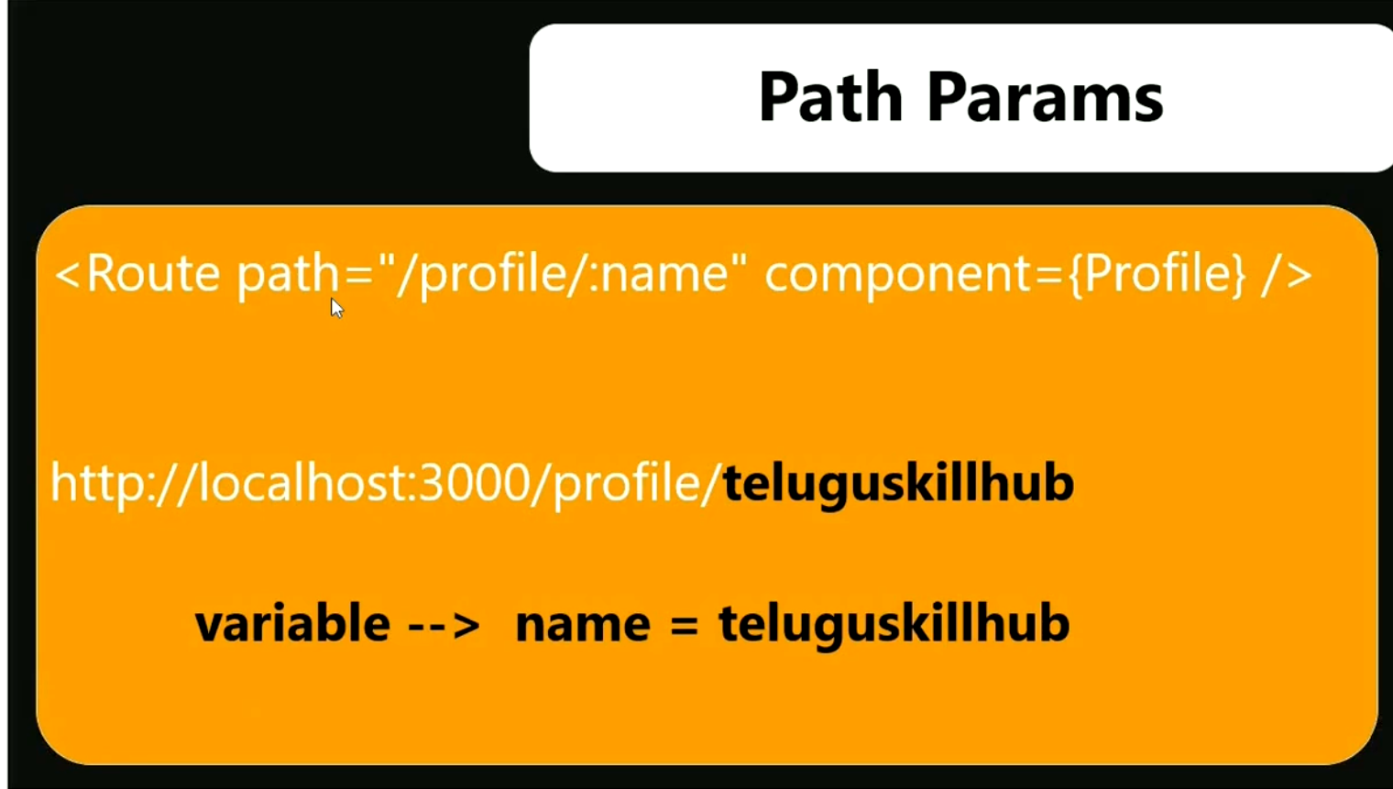

**Query Params :**

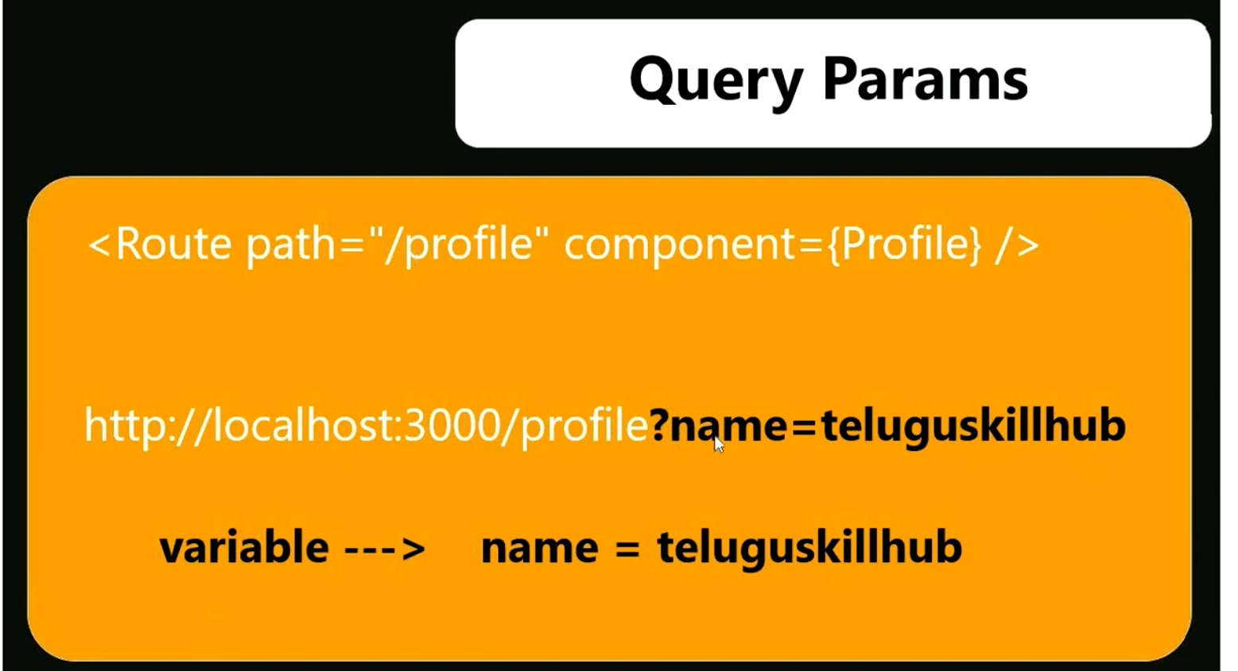

**Images Import :**

import RajPhoto from './raj.jpg'

export const ImagesNuera=()=>{

    return(

        <div>

            <img src={RajPhoto} style={{marginLeft:"10px"}} height="300px" alt='not_found'></img>

        </div>

    )

}

**Audio Import :**

import Song from './i_song.mp3'

export const AudioNuera=()=>{

    return(

        <div>

            <audio controls>

               My file <source src={Song} type='audio/ogg'/>

            </audio>

        </div>

    )

}

**Video Import:**

import VideoFile from './test_video.mp4'

export const VideoNuera=()=>{

    return(

        <div>

            <video controls height="300px" width="300px">

               My file <source src={VideoFile} type='video/mp4'/>

            </video>

        </div>

    )

}

**Redux :**

**If declare one variable by using Redux…we ca use at any component or anywhere we can use…**

**If we change value at any component..it wil update all the components**

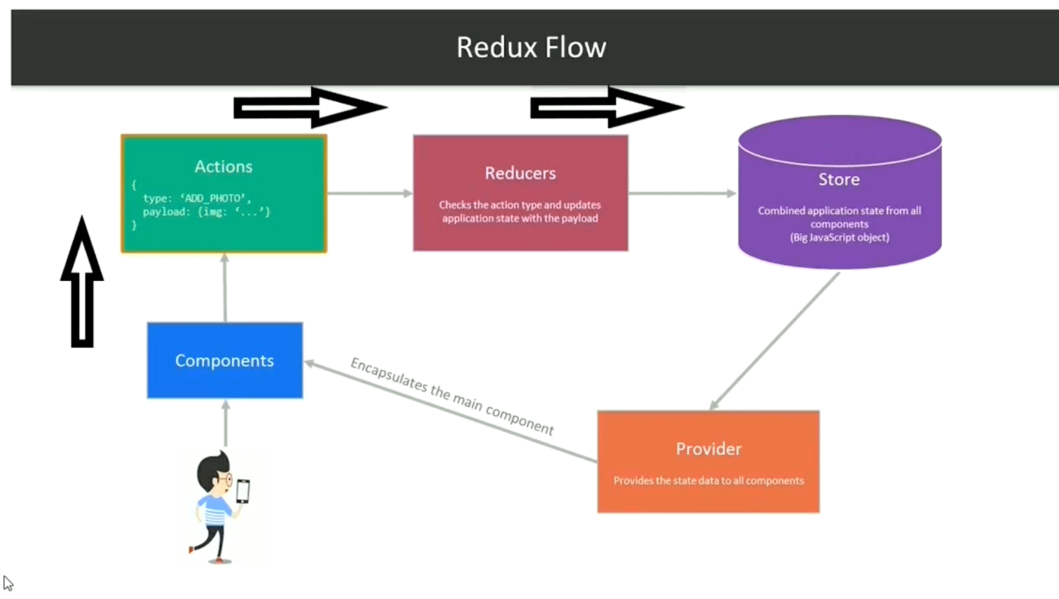

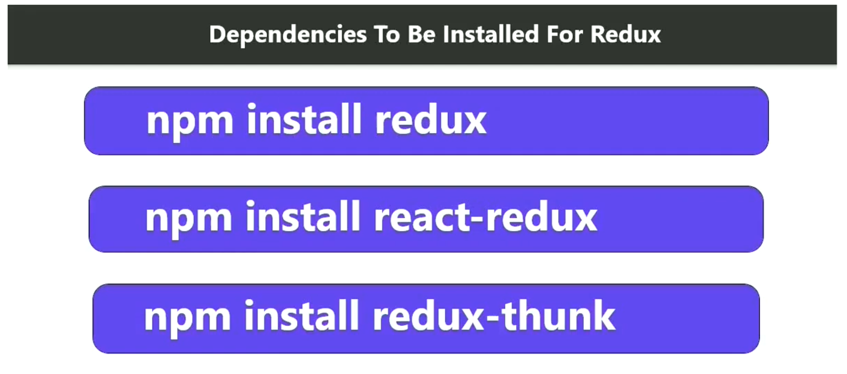

**App.js:**

import { connect } from "react-redux"

import { InAction } from "./redux/actions_Nuera"

import { DeAction } from "./redux/actions_Nuera"

const App=({local_variable,InAction,DeAction})=>{

  return(

    <div>

      <center>

        <h1>{local_variable}</h1>

        <button onClick={InAction}>Increment</button>

        <button onClick={DeAction}>Decrement</button>

      </center>

    </div>

  )

}

const mapStateToProps=state=>({

  local_variable:state

})

export default connect(mapStateToProps,{InAction,DeAction})(App);

**Store.js :**

import {applyMiddleware} from 'redux';

import { legacy_createStore as createStore } from 'redux';

import thunk from "redux-thunk";

import { composeWithDevTools } from 'redux-devtools-extension';

import reducer from './reducer_Nuera';

const middleware=[thunk]

const store=createStore(

    reducer,

    composeWithDevTools(

        applyMiddleware(...middleware)

        ))

export default store

**reducer.js**

const count=5;

export default function reducer(state=count,action){

    const{type,payload}=action;

    switch(type){

        case "INCREMENT":

            return state+1;

        case "DECREMENT":

            return state-1;

        default :

            return state;

    }

}

**Actions.js**

export const InAction=()=>async dispatch=>{

    dispatch({

        type:"INCREMENT"

    })

}

export const DeAction=()=>async dispatch=>{

    dispatch({

        type:"DECREMENT"

    })

}

**Index.js**

import store from './redux/store_Nuera';

import { Provider } from 'react-redux';

<React.StrictMode>

    <Provider store={store}>

      <App />

    </Provider>

  </React.StrictMode>

**Download :**

import RajPhoto from './raj.jpg'

export const Download=()=>{

    return(

        <div>

            <img src={RajPhoto} style={{marginLeft:"10px"}} height="300px" alt='not_found'></img>

            <a href={RajPhoto} download='raj'>Download</a>

        </div>

    )

}

**SearchFilter :**

import { useState } from "react"

import Data from './data_Nuera.json'

export const SearchFilter=()=>{

    const [search,newSearch]=useState('');

    return(

        <div>

            <center>

                <h4>Enter The City Name : {search}</h4>

                <input value={search} onChange={(e)=>{newSearch(e.target.value)}} />

                <br/>

                {Data.filter(city=>city.name.toLowerCase().includes(search.toLowerCase())).map(city=>{return(<div style={{"border":"2px solid black",paddingTop:"10px","margin":"10px",paddingBottom:"10px",maxWidth:"50%"}}>{city.name}</div>)})}

            </center>

        </div>

    )

}

**useRef :**

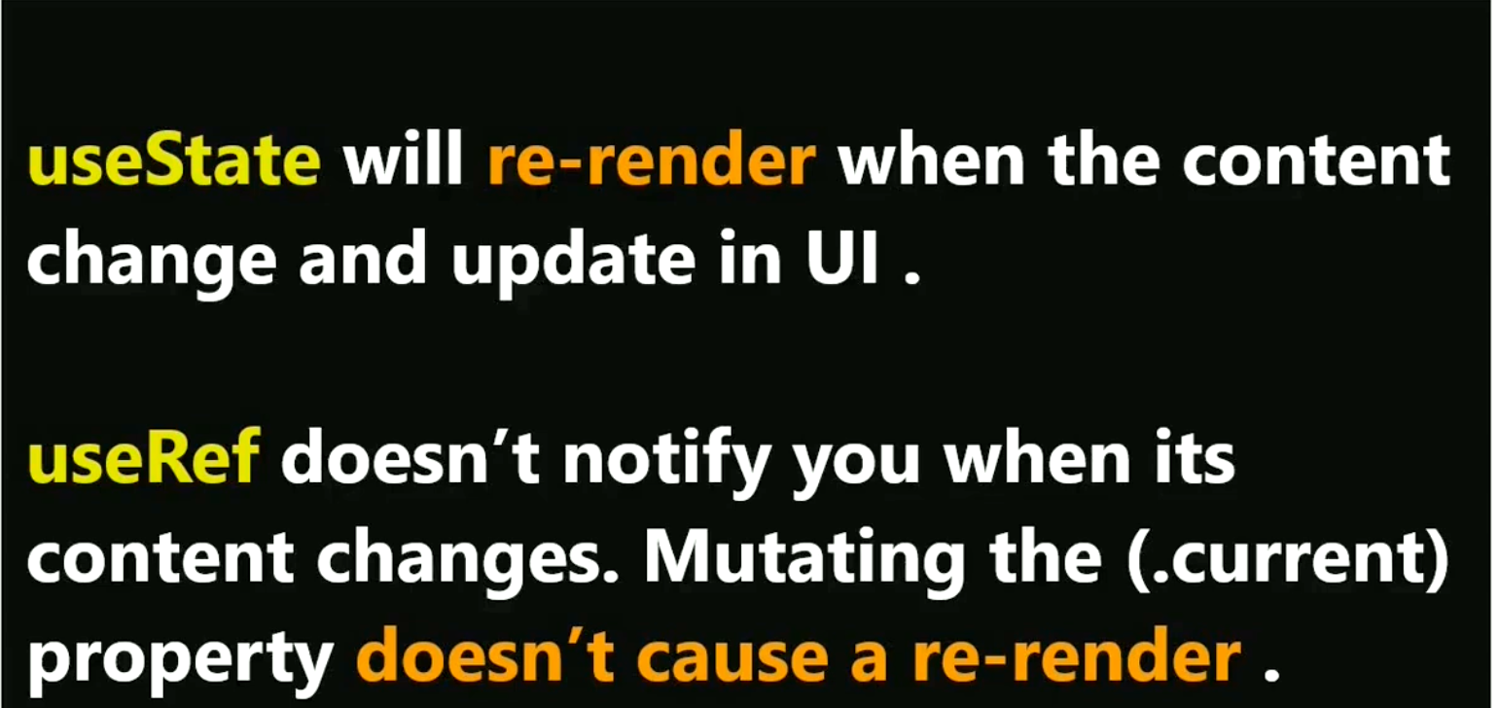

**Its also supports autofocussing , whenever the load the page , the cursor automatically moves to the fields**

import React,{useRef,useEffect} from "react";

export const UseRefNuera=()=>{

    const data=useRef(0)

    const onSubmitHandler=e=>{

        e.preventDefault()

        console.log(data.current.value)}

        useEffect(()=>{

        data.current.focus();

    },[])

    return(

        <div>

            <form onSubmit={onSubmitHandler}>

                <input ref={data} type="text" placeholder="enter the name"/><br/>

                <input type="submit" value="Submit"/>

            </form>

        </div>

    )

    }

**useReducer :**

**it is also similar to redux**

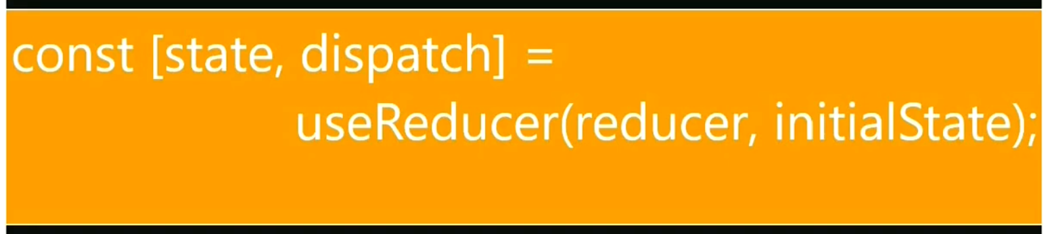

import React,{useReducer} from "react";

const initialState={count:0};

const reducer=(state,action)=>{

    switch(action.type){

        case 'increment':

            return({count:state.count+1})

        case 'decrement':

            return({count:state.count-1})

        default:

            throw Error();

    }

}

export const UseReducerNuera=()=>{

    const[state,dispatch]=useReducer(reducer,initialState)

    return(

        <center>

            <div>

                {state.count}

                <button onClick={()=>dispatch({type:"increment"})}>+</button>

                <button onClick={()=>dispatch({type:"decrement"})}>-</button>

            </div>

        </center>

    )

}

**Context Api:**

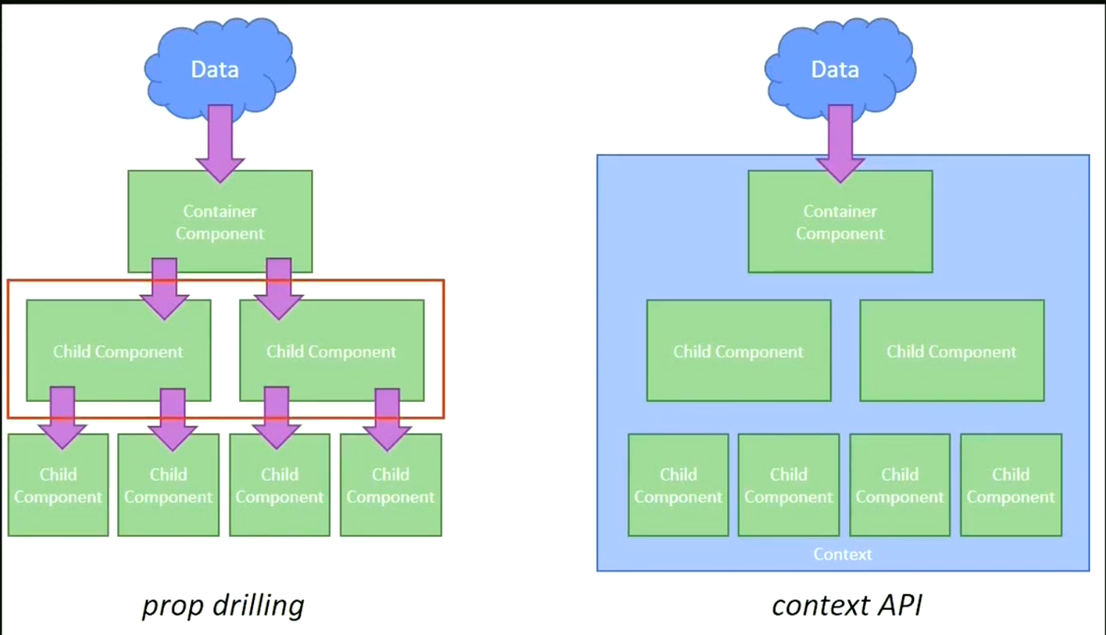

**In App.js**

import { ComponentANuera } from './context_api/component_A'

import { ComponentBNuera } from './context_api/component_B'

import { createContext,useState } from 'react'

export const store=createContext();

const App=()=>{

  const [past,now]=useState(0)

  return(

    <store.Provider value={[past,now]}>

      <center>

        <ComponentANuera/>

        <ComponentBNuera/>

        <button onClick={()=>now(past+1)}>ClickMe</button>

      </center>

    </store.Provider>

  )

}

export default App

**Component_A.js**

import React,{useContext} from "react";

import { store } from "../App";

export const ComponentANuera=()=>{

    const [past,now]=useContext(store)

    return(<div>

        <h1>from component A : {past}</h1>

    </div>)

}

**Component_B:**

import React,{useContext} from "react";

import { store } from "../App";

export const ComponentBNuera=()=>{

    const [past,now]=useContext(store)

    return(<div>

        <h1>from component B : {past}</h1>

    </div>)

}